

Name(s): ___KEY!!!!!!!!!!!!!!!!!!_____

Number of Questions Correct: _10__

Time of Completion: ________________

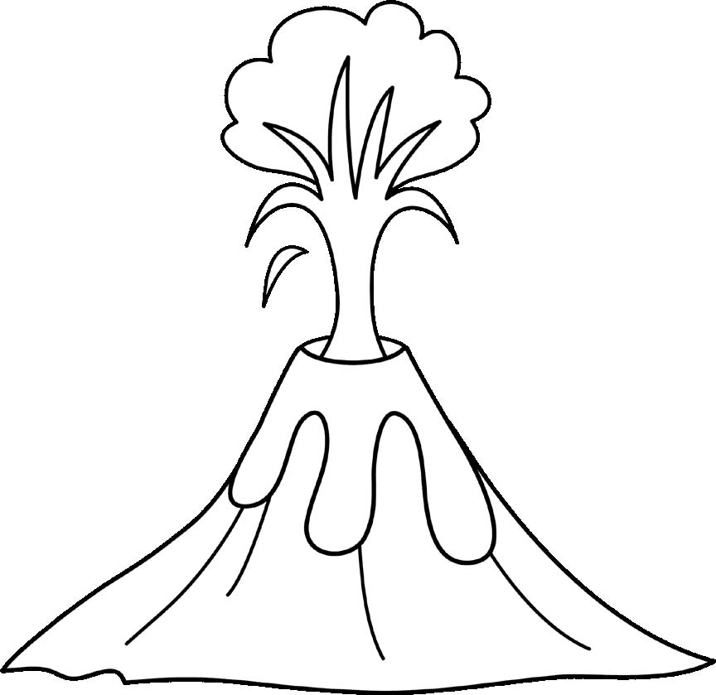
- What is the volcano with the second highest elevation in California? Lassen Peak
- How many volcanoes in Washington are over 4,000 meters in elevation? One

- Which volcanoes have lava flow hazards? All except Mount Jefferson and Crater Lake
- How many volcanoes in Oregon are stratovolcanoes? Three

- What volcano in California, Oregon, and Washington is most recently active? Mount St Helens
- What volcano in California, Oregon, and Washington hasn’t been active in the longest amount of time? Mount Jefferson in the Ice Age

- What is the volcano with the lowest elevation in Washington? Mount St Helens

- What is the most common hazard in California volcanoes? Lava flows and domes, pyroclastic flows, lahars all equally likely

- How many volcanoes in California, Oregon, and Washington have been active after the year 1900? Three

- What do Medicine Lake and Newberry Crater Volcanoes have in common? Both Shield Volcanoes (other possible correct answers)

